Procedure to Check Cigna Claim Status
To check Cigna claim status need to login to below URL.
URL : https://cignaforhcp.cigna.com/app/login
Below is the screenshot of the page where we need to Enter the username and password, and click on Sign In or the page to be redirected to Verification of Identity code.
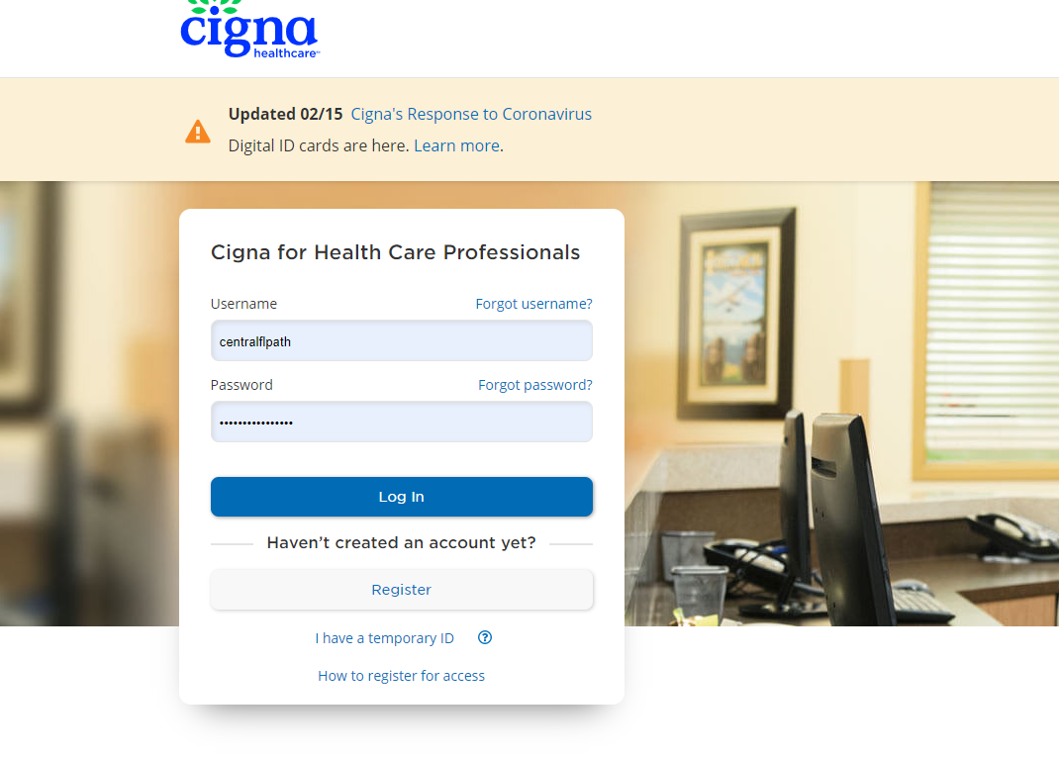

Once we get redirected to the Two-Step Authentication, a code will be sent to the registered Email ID. need to enter the code in the space given and select Don't ask me for a code the next time I log in to avoid entering the code for furure logins.
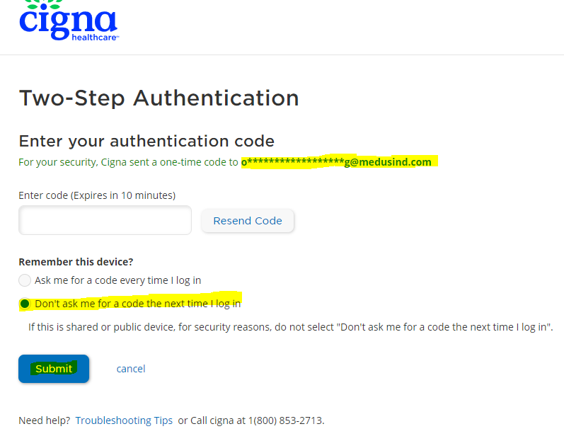
Then click on Submit for the portal.
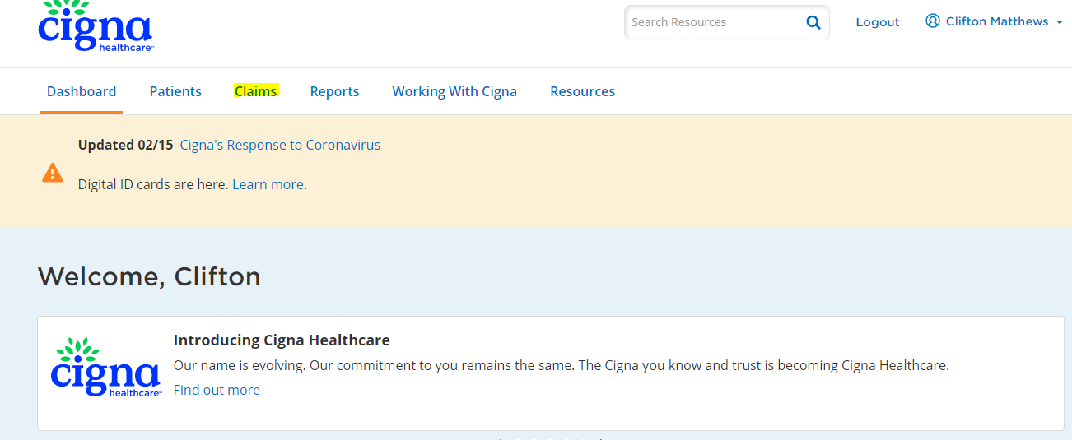
Once logged in click on the Claims to check the claim status.
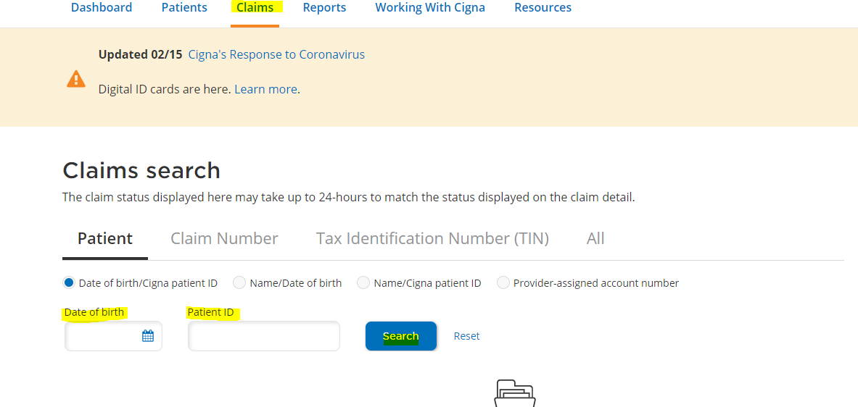
Now we need to enter the Member ID & Date of Birth and click on search for claim status.
To get the patient details need to login to Medclarity.
Login to Medclarity - > Select “Orlando” in Enterprise -> Type the first word of the Entity name -> Click the Practice name from the Business Entity Search.
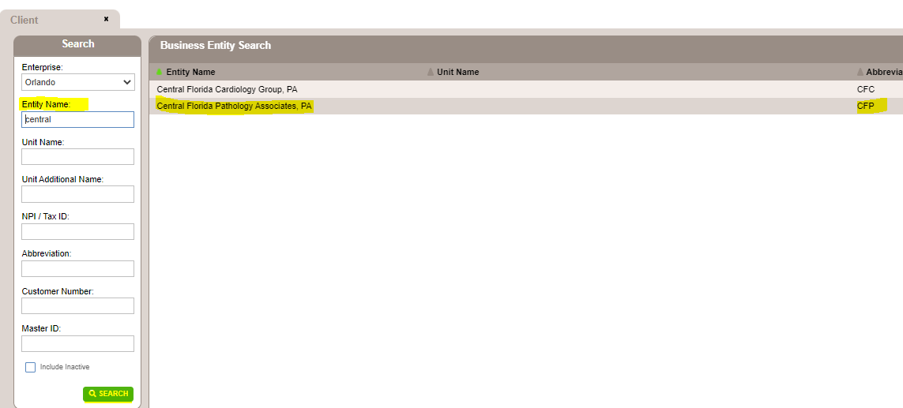
Once the practice opens, click the “Reimbursement” with the "$" Symbol
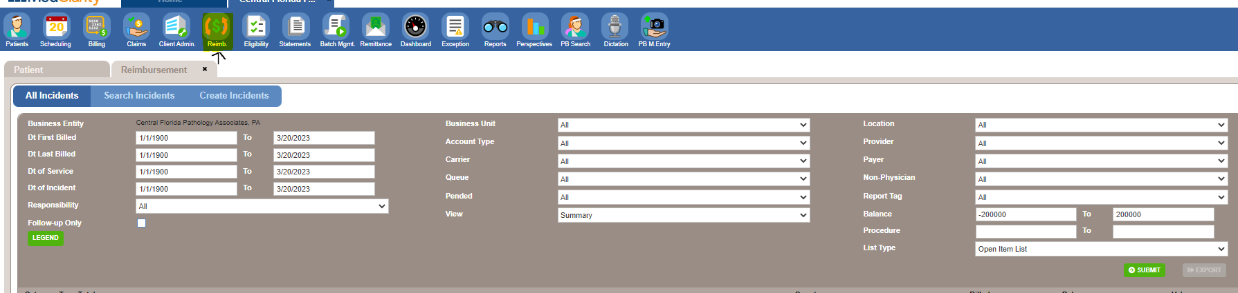
Then Click on dropdown in Queue and select Queue for No response claims.
Then Click the dropdown in the View tab and select “Details” and click on Submit to view the list of claims in the Queue.

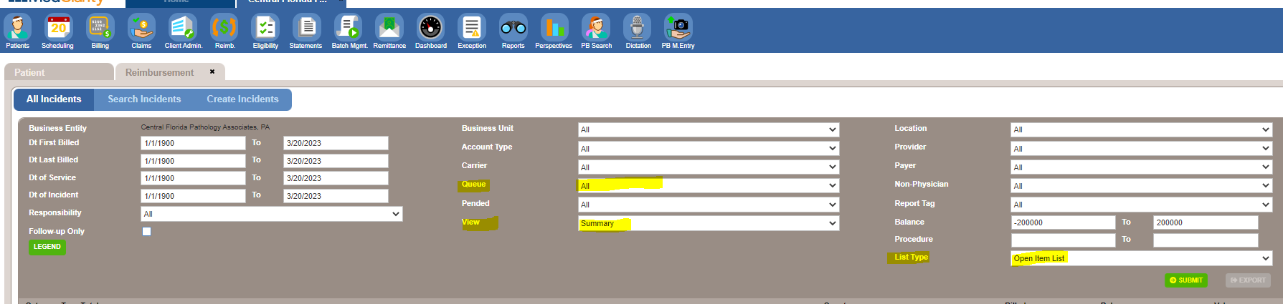
To find the claim, we can do "CTRL+F", then click the Claim ID, it will show you the CPT details billed in the claim.
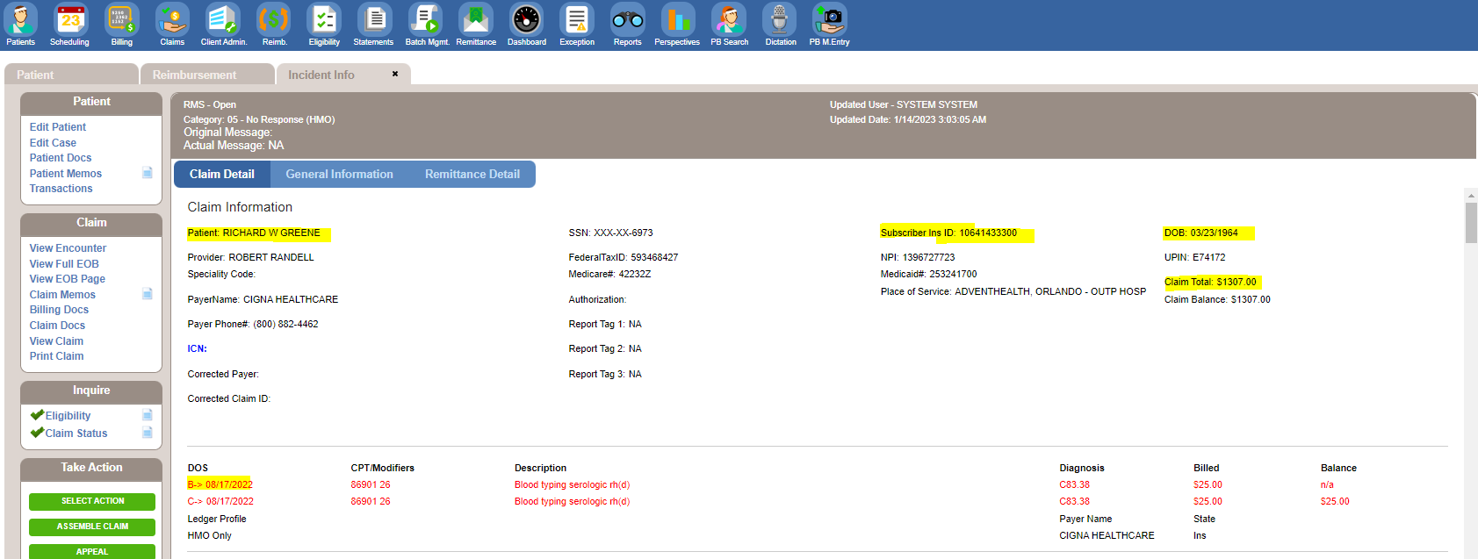

Now we have the patient information to check the claim status, enter the same in Cigna portal.
Once all the Mandatory fields are entered need to click on Search which will pull the Claim status.
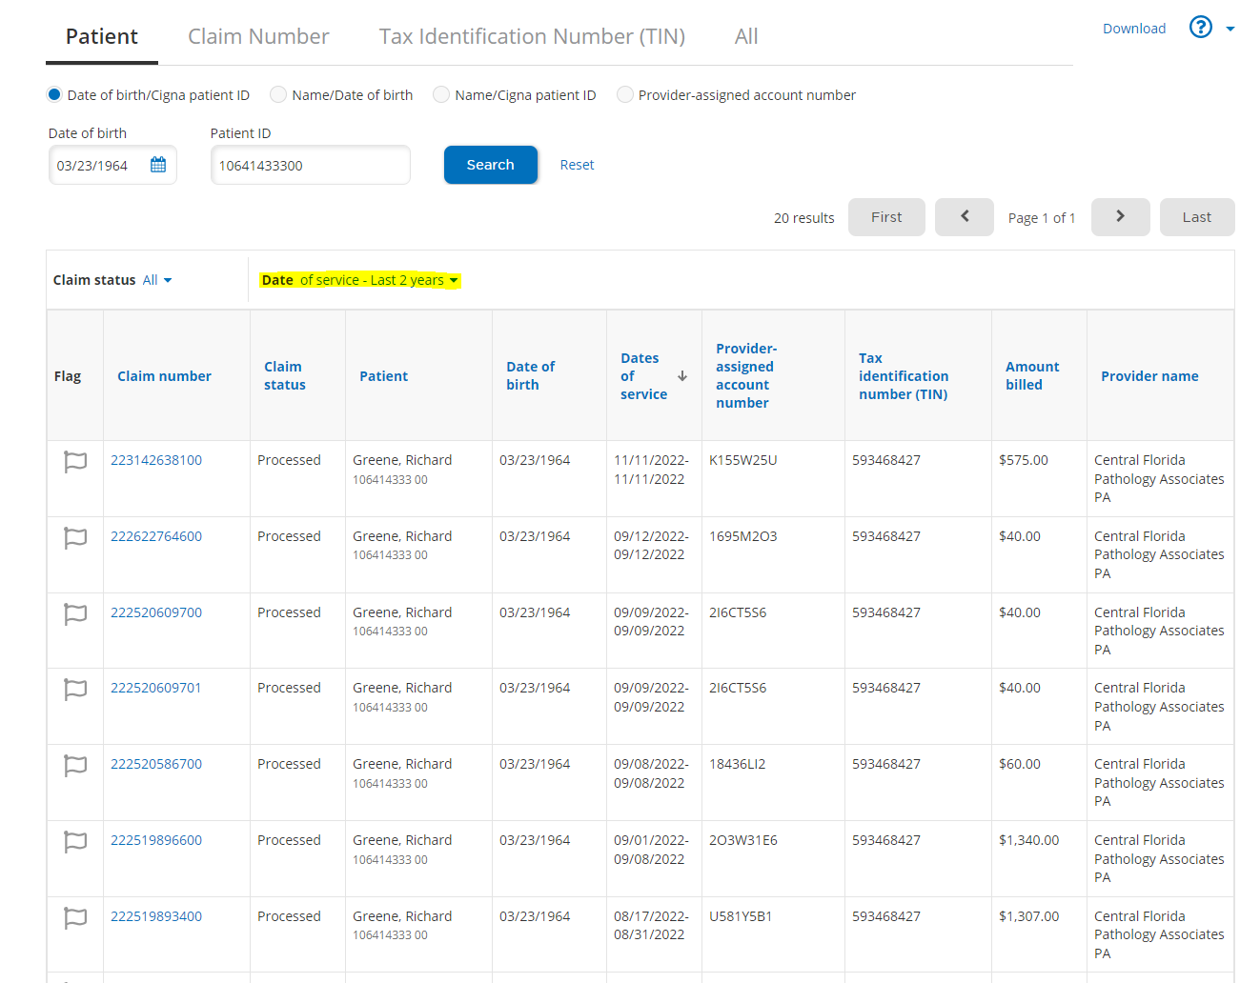

To filter the claim only for our date of service on the Drop down near Date. and the select the Date option to Custom Date Range, to enter the DOS.
Then click on Apply for the Change in Date range.

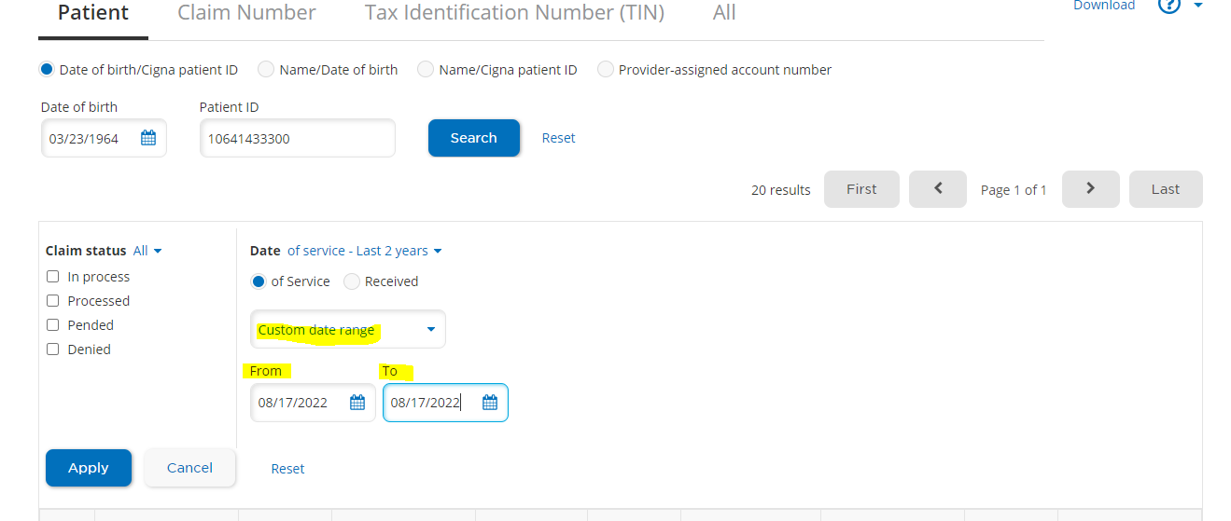

Now we have to click on Claim number to display the detailed claim status.
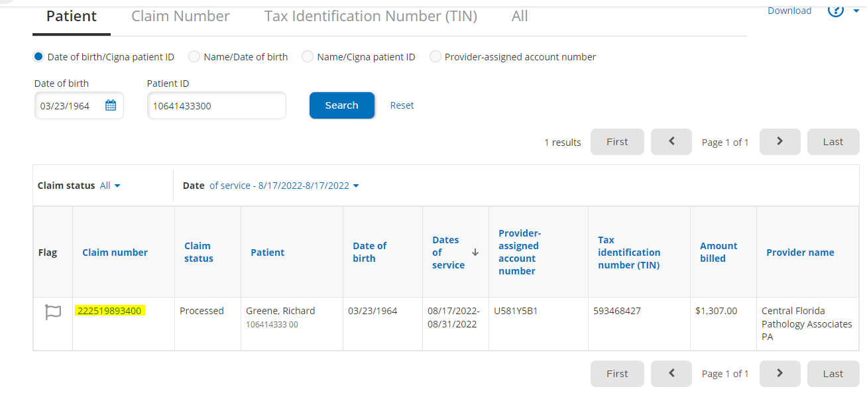

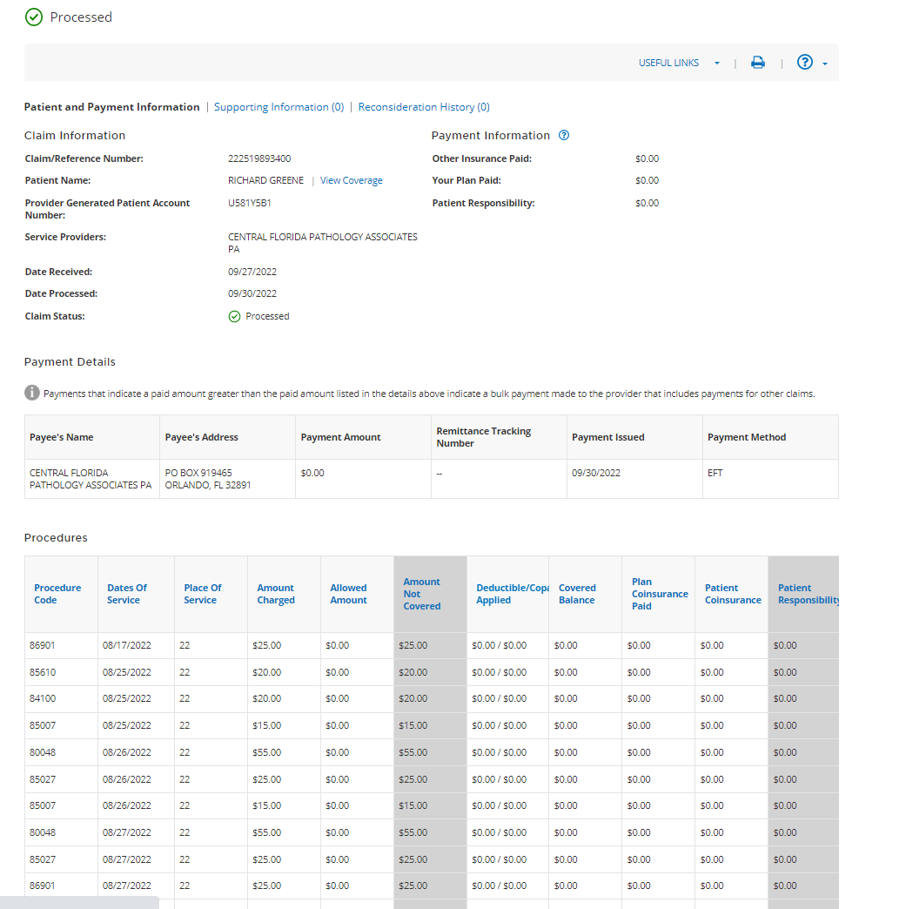

If we have to check patient Elligibility, need to click on View coverage highlighted in Blue, this will provide the eligibility for the patient for the DOS on the claim.
If we want to download full EOB, Scroll to the bottom of the page for Remittance report, where we can click on View PDF for the Full EOB.
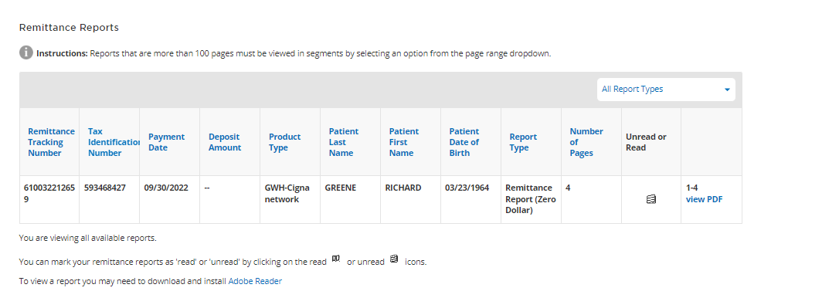
If we have to check Eligibility for Other DOS need to check manually by Clicking on the Patients on the top, there we can check eligibility for other DOS.
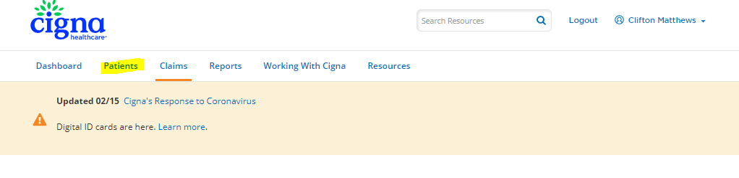
Need to Enter patient's ID Number or SSN and DOB or First Name and Last Name and Date of service. Also the Date of service.

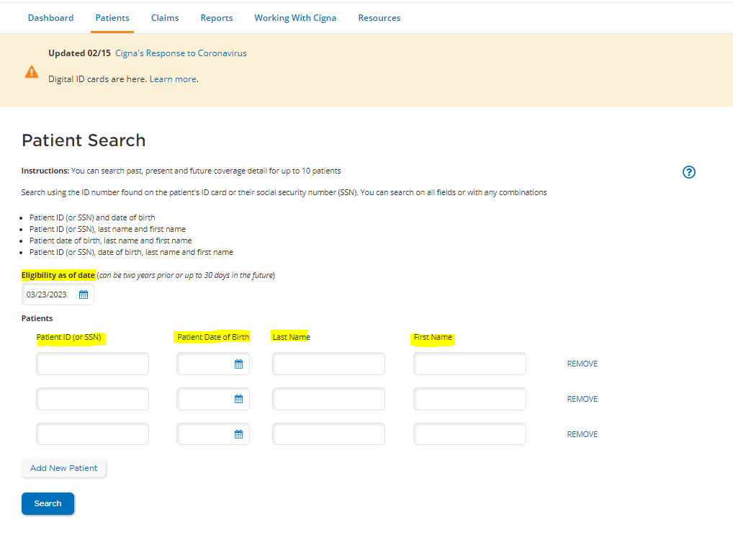
Then click on Search for patient Eligibility status
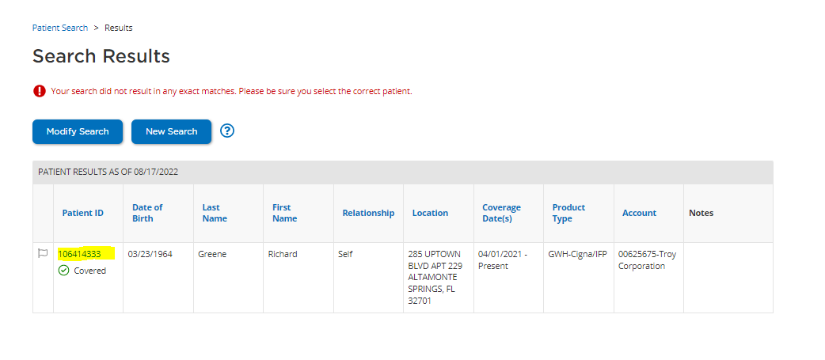

Once we click on the Patient ID number, there will be a pop for patient verification, in which we have to select Confirm Patient.

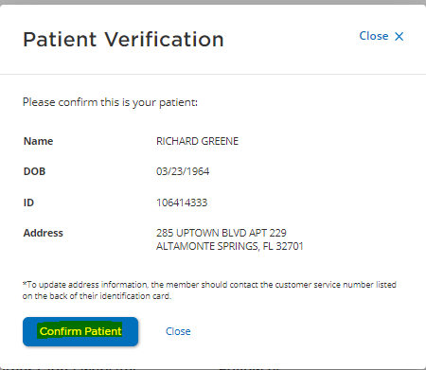

This will display the detailed eligibility status.

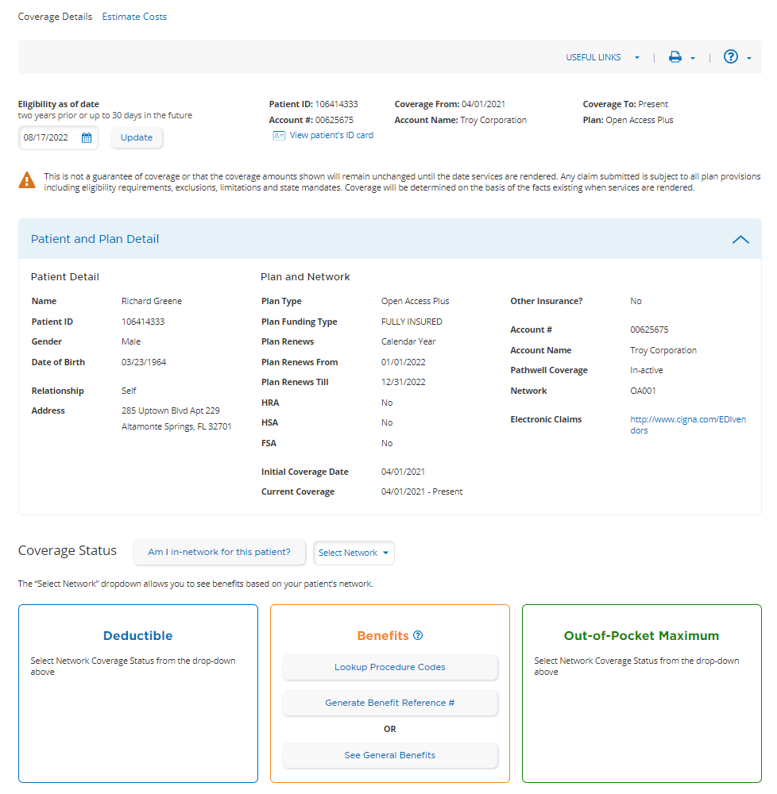

sss

